CASE STUDY 3: CAMPUS EVENT FINANCIAL PLANNING SYSTEM
BUDGET MODELING, REVENUE PROJECTIONS, AND BREAK-EVEN AUDIT
1 PROBLEM STATEMENT
Build a comprehensive financial modeling utility for campus event management. The system must process fixed expenses, per-head variable costs, expected attendee counts, sponsorship inflows, and ticket prices to generate a complete budget report and break-even analysis.
PDF+ 1
2 OBJECTIVES
- Aggregate itemized fixed operational costs and variable attendee expenses.
PDF
- Compute total projected revenue from sponsorships and registration fees.
PDF
- Determine net surplus or deficit financial position.
PDF
- Calculate the exact minimum attendee registration count required to break even.
PDF
3 KEY ASSUMPTIONS
Variable expenses increase linearly with student participation. Sponsorship funds are guaranteed fixed inputs.
PDF+ 1
4 ALGORITHM
- Sum fixed costs (venue, audio, marketing, honorarium).
PDF
- Calculate total variable cost = per_person_cost * expected_attendees.
PDF
- Total expenses = Fixed costs + Total variable costs.
PDF
- Total revenue = Sponsorships + (fee_per_student * expected_attendees).
PDF
- Net Balance = Total revenue - Total expenses.
PDF
- Break-even count = (Fixed costs - Sponsorships) / (Fee per student - Variable cost per student).
PDF
5 FLOWCHART REPRESENTATION
Plaintext
[Start] -> [Input Fixed Costs, Variable Rate, Sponsorship, Ticket Fee]
-> [Calc Total Exp = Fixed + (Var * Count)]
-> [Calc Total Rev = Sponsor + (Fee * Count)]
-> [Calc Net Balance = Rev - Exp] -> [Calc Break-Even Count] -> [Display Budget Report] -> [End]
```[cite: 5]

## 6 PSEUDOCODE
```text
FUNCTION model_event_budget(fixed_list, var_per_head, attendees, sponsor, ticket_fee):
total_fixed = SUM(fixed_list)
total_exp = total_fixed + (var_per_head * attendees)
reg_revenue = ticket_fee * attendees
total_revenue = sponsor + reg_revenue
net_balance = total_revenue - total_exp
net_status = "SURPLUS" IF net_balance >= 0 ELSE "DEFICIT"
break_even = CEIL((total_fixed - sponsor) / (ticket_fee - var_per_head))
PRINT Financial Report summary
```[cite: 6]

## 7 PYTHON SOURCE CODE
```python
import math

fixed_costs = {"Auditorium": 15000, "Sound & Light": 8000, "Certificates": 5000}
var_cost_per_head = 300
expected_attendees = 120
ticket_fee = 500
sponsorship = 20000

tot_fixed = sum(fixed_costs.values())
tot_var = var_cost_per_head * expected_attendees
tot_expenses = tot_fixed + tot_var

reg_rev = ticket_fee * expected_attendees
tot_revenue = sponsorship + reg_rev
net_bal = tot_revenue - tot_expenses

contribution_margin = ticket_fee - var_cost_per_head
net_fixed_needed = tot_fixed - sponsorship
break_even_students = math.ceil(net_fixed_needed / contribution_margin) if contribution_margin > 0 else "N/A"

status = "SURPLUS" if net_bal >= 0 else "DEFICIT"

print("=== CAMPUS EVENT FINANCIAL BUDGET REPORT ===")
print(f"Total Fixed Expenses : Rs. {tot_fixed}")
print(f"Variable Cost per Person : Rs. {var_cost_per_head}")
print(f"Total Projected Expenses : Rs. {tot_expenses}")
print(f"Sponsorship Funds : Rs. {sponsorship}")
print(f"Registration Fee Revenue : Rs. {reg_rev}")
print(f"Net Financial Balance : Rs. {abs(net_bal)} ({status})")
print(f"Minimum Registrations to Break-Even: {break_even_students} students")
```[cite: 6]

## 8 TEST CASES
| Attendees | Ticket Fee | Net Balance | Break-Even Point |
| :--- | :--- | :--- | :--- |
| **120 students**[cite: 6] | Rs. 500[cite: 6] | Rs. 16000 (SURPLUS)[cite: 6] | 40 students[cite: 6] |
| **30 students**[cite: 6] | Rs. 500[cite: 6] | Rs. -2000 (DEFICIT)[cite: 6] | 40 students[cite: 6] |

## 9 OUTPUT SCREENSHOTS
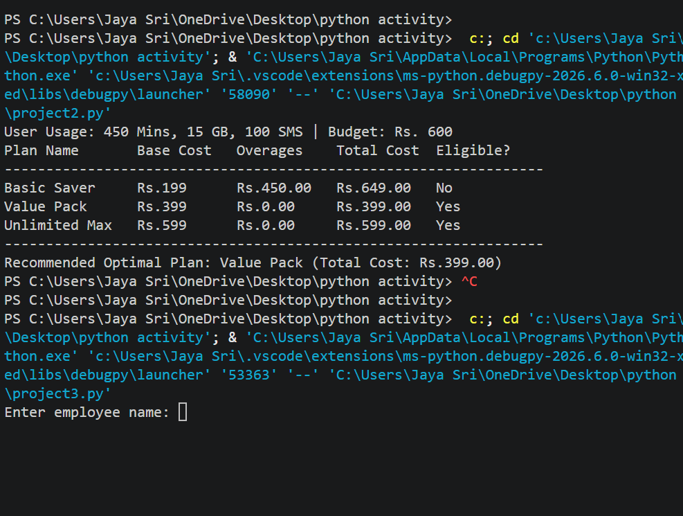
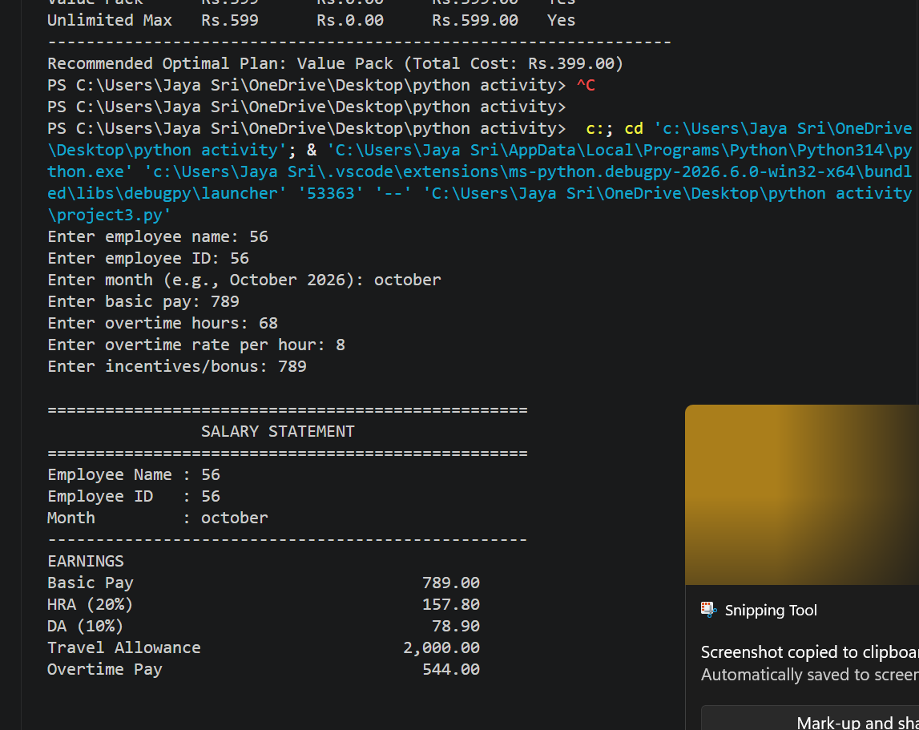
## 10 CONCLUSION
The financial planning system successfully models income streams, operational costs, and break-even thresholds to guide event budgeting decisions[cite: 5, 6].<ElicitationsGroup>

